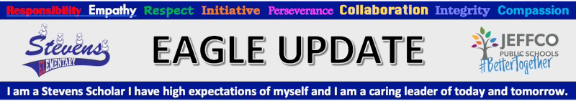
Office 303-982-2198 Attendance Line 303-982-2180

Calendar
Mon 9/6 | No School - Labor Day
Tues 9/7 | After school Clubs start - sign up sheets will go home Monday 8/23
Thu 9/9 | 6pm PTO Meeting on Zoom Link
Wed 9/15 | Jeffco GT Info Night
Wed 9/22 | Picture Day - We need a few volunteers on this day. If interested please contact Miss Vicki in the office 303-982-2198 vicki.zeimen@jeffco.k12.co.us
Fri 9/24 | 3:15pm - Kona Ice Truck at school
Tue 9/28 | Parent/Teacher conferences
Wed 9/29 | Field Day for all students (rain day Oct 6)
Thu 9/30 | Parent/Teacher conferences
Fri 10/1 | October count day for school funding - Students must be at school to be counted!
Thu 10/7 | No School, Teacher work day
Fri 10/8 | No School, Fall Break

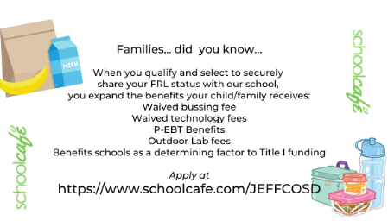
English
https://forms.gle/gnoTRYL2GuzgE1BP7
Spanish
https://forms.gle/RUYwWT45Mt91h7Su7
Apply for Free & Reduced at
https://www.schoolcafe.com/JEFFCOSD

- Don’t forget to fill out your Free and Reduced Meal application, see info above.
- Students must have arrangements to leave school grounds promptly at 3:20. Whether walking home or getting picked up this is when the school day ends.
- All toys should be left at home. The school is not responsible for toys brought from home.
- Please call the Attendance line 303-982-2180 each day your student is absent.
- If anyone in the household is getting a Covid test, please let us know and keep students home till the results are in.
- Updated - Possible COVID-19 symptoms: new or recent loss of taste or smell; cough; shortness of breath; fever; runny nose; congestion; sore throat; headaches; nausea, vomiting and/or diarrhea. Jeffco COVID Protocols Operations Guide for Families
- Jeffco Schools Code of Conduct/Discipline

Community Table will distribute sacks filled with weekend food to students participating in the Colorado Free or Reduced Lunch Program. The bags consist of food for breakfasts, lunches and snacks for your child (children). The food will be packed in a plastic sack and will fit in your child’s backpack.
If you wish for your child (children) to participate in this program, please complete this FORM and submit the results by clicking the “DONE” icon at the bottom.
After School Clubs - Clubs are offered on a first-come, first-served basis. Our 1st session of after-school clubs will run: September 8th to December 15th, 2021, Monday to Thursday from 3:30 pm to 4:30 pm. We still have room in Coding K-2, Adventure Leadership 3rd-5th, Remote Cooking K-5th 5-6pm on zoom starting Oct 14. Registration Link
Friends of Stevens PTO: Friends of Stevens would love for you to join us in to providing students at Stevens Elementary School with materials and tools to learn in a hands-on ways and to support and lift up our teachers and staff.
Please contact our PTO President, Jen Cross if you’d like more info. or if you have any questions regarding Friends of Stevens PTO, jenbowencross@gmail.com.
Meeting schedule: Zoom Link
Sept 9th - 6pm
Nov 11th - 6pm
Jan 13th - 6pm
Mar 10 - 6pm
May 12 - 6pm

